**Lab Report: 06**

**Title: Liang-Barsky algorithm for line clipping**

*Course title: Computer Graphics Laboratory*

*Course code: CSE-304*

*3rd Year 1st Semester Examination 2022*

**Date of Submission**: 13/08/2023



**Submitted to-**

**Dr. Mohammad Shorif Uddin**

*Professor*

*Department of Computer Science and Engineering*

*Jahangirnagar University*

*&*

**Dr. Morium Akter**

*Associate Professor*

*Department of Computer Science and Engineering*

*Jahangirnagar University*

*Savar, Dhaka-1342*

|  |  |  |
| --- | --- | --- |
| Class Roll | Exam Roll | Name |
| 353 |  | Shanjida Alam |

**Source Code:**

#include <iostream>

#include <graphics.h>

using namespace std;

const int xmax = 300;

const int xmin = 50;

const int ymax = 500;

const int ymin = 250;

bool clipT(double p, double q, double& t1, double& t2)

{

double r;

if (p<0.0)

{

r=q/p;

if (r>t2)

{

return false;

}

if (r>t1)

{

t1=r;

}

}

else if (p>0.0)

{

r=q/p;

if (r<t1)

{

return false;

}

if (r<t2)

{

t2=r;

}

}

else if (q<0.0)

{

return false;

}

return true;

}

void liangBarskyClip(double x1, double y1, double x2, double y2)

{

double t1=0.0, t2=1.0, dx=x2 - x1,dy;

if (clipT(-dx,x1-xmin,t1,t2) && clipT(dx,xmax-x1,t1,t2))

{

dy=y2-y1;

if (clipT(-dy,y1-ymin,t1,t2) &&

clipT(dy,ymax-y1,t1,t2))

{

if (t2<1.0)

{

x2=x1+t2*dx;

y2=y1+t2*dy;

}

if (t1>0.0)

{

x1+=t1*dx;

y1+=t1*dy;

}

line(x1,y1,x2,y2);

}

}

}

int main()

{

int gd = DETECT, gm;

initgraph(&gd, &gm, "");

initwindow(1000, 1000);

rectangle(xmin, ymin, xmax, ymax);

line(0, 300, 150, 550);

line(150, 450, 350, 600);

line(100, 350, 250, 300);

line(250, 100, 350, 350);

line(0, 550, 100, 700);

int fillGd = DETECT, fillGm;

initgraph(&fillGd, &fillGm, " ");

initwindow(1000, 1000);

rectangle(xmin,ymin,xmax,ymax);

liangBarskyClip(0, 300, 150, 550);

liangBarskyClip(150, 450, 350, 600);

liangBarskyClip(100, 350, 250, 300);

liangBarskyClip(250, 100, 350, 350);

liangBarskyClip(0, 550, 100, 700);

getch();

closegraph();

closegraph();

return 0;

}

**Output:**

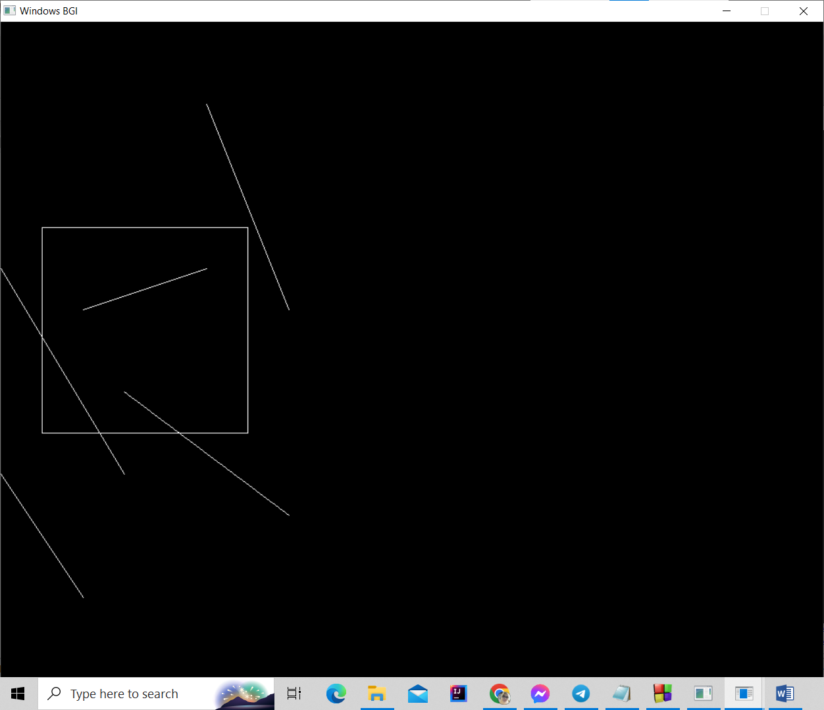

**Fig: The given viewport and lines**

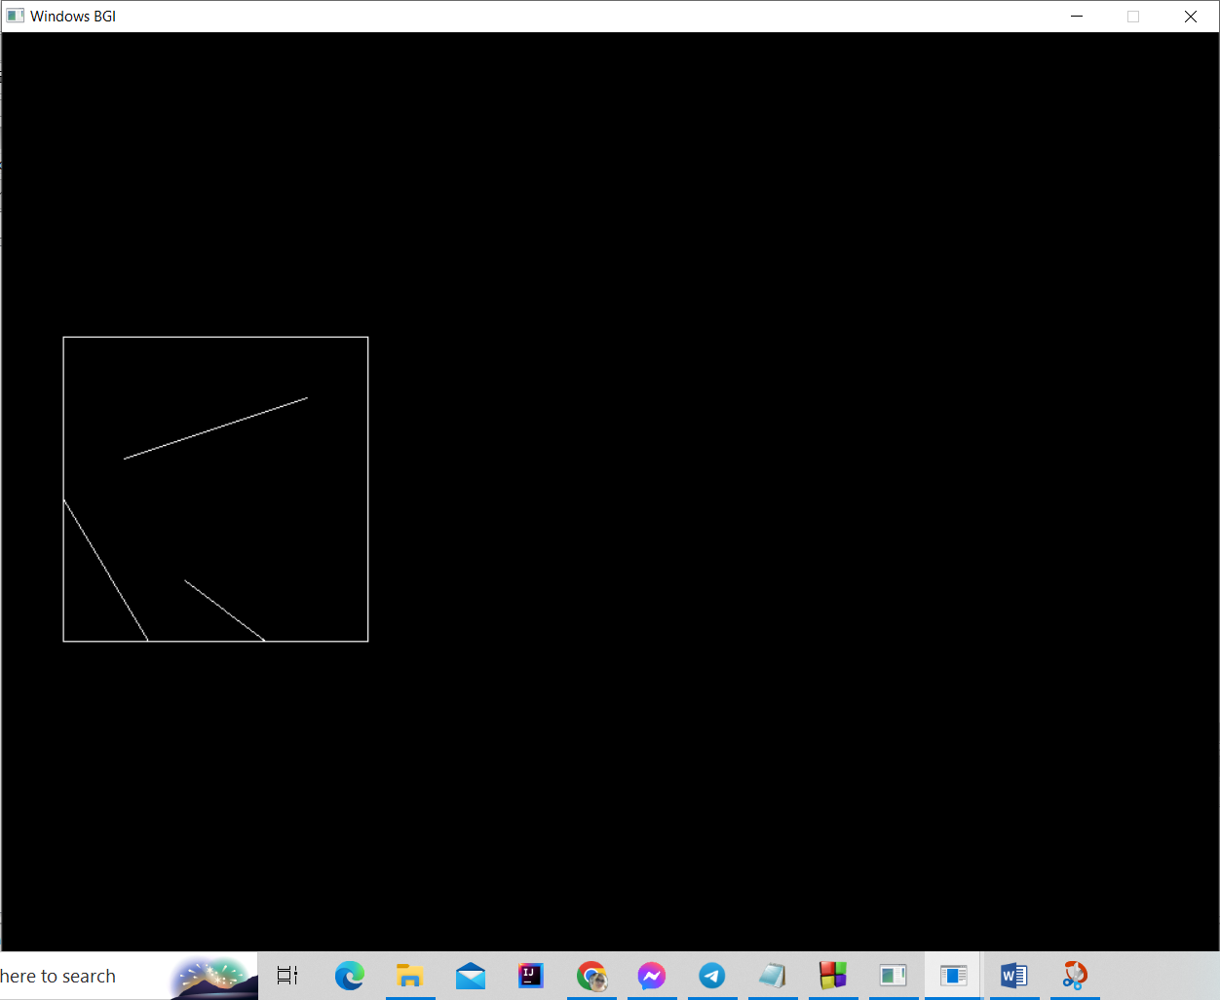

**Fig: Clipped lines**